Devops Build

Docker:
Commands Used:
Vim DockerFile

Vim docker-compose.yaml
docker-compose up -d
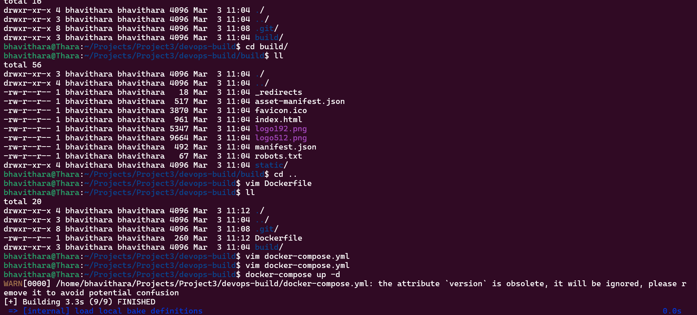

http://localhost:80

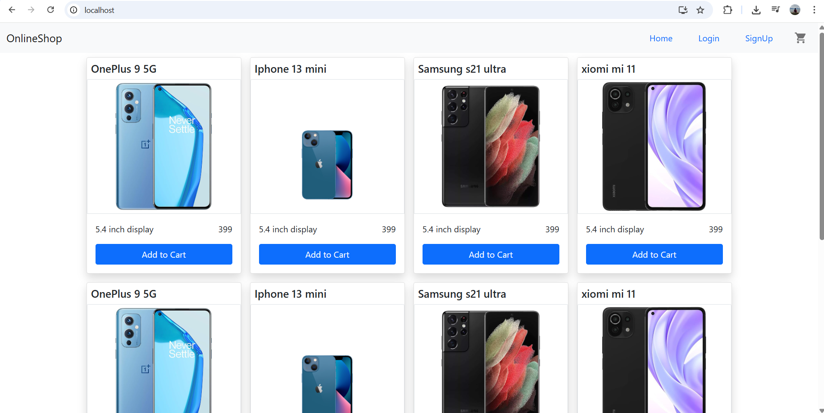

Bash Script:
Build.sh
#!/bin/bash

# Set image name and tag
IMAGE_NAME="bhavidocker/dev-app"
TAG="latest"

# Build Docker image
docker build -t $IMAGE_NAME:$TAG .

echo "Docker image built: $IMAGE_NAME:$TAG"

Deploy.sh
#!/bin/bash

IMAGE_NAME="bhavidocker/dev-app"
TAG="latest"

docker login -u $DOCKER_USERNAME -p $DOCKER_PASSWORD
docker push $IMAGE_NAME:$TAG

echo "Docker image pushed to Docker Hub: $IMAGE_NAME:$TAG"

to make both scripts executable - chmod +x build.sh deploy.sh

Version Control:
.gitignore
node_modules
.env
Dist

. dockerignore
node_modules
.git
Dockerfile
docker-compose.yml

git init
git add .
git commit -m “commited”
git push

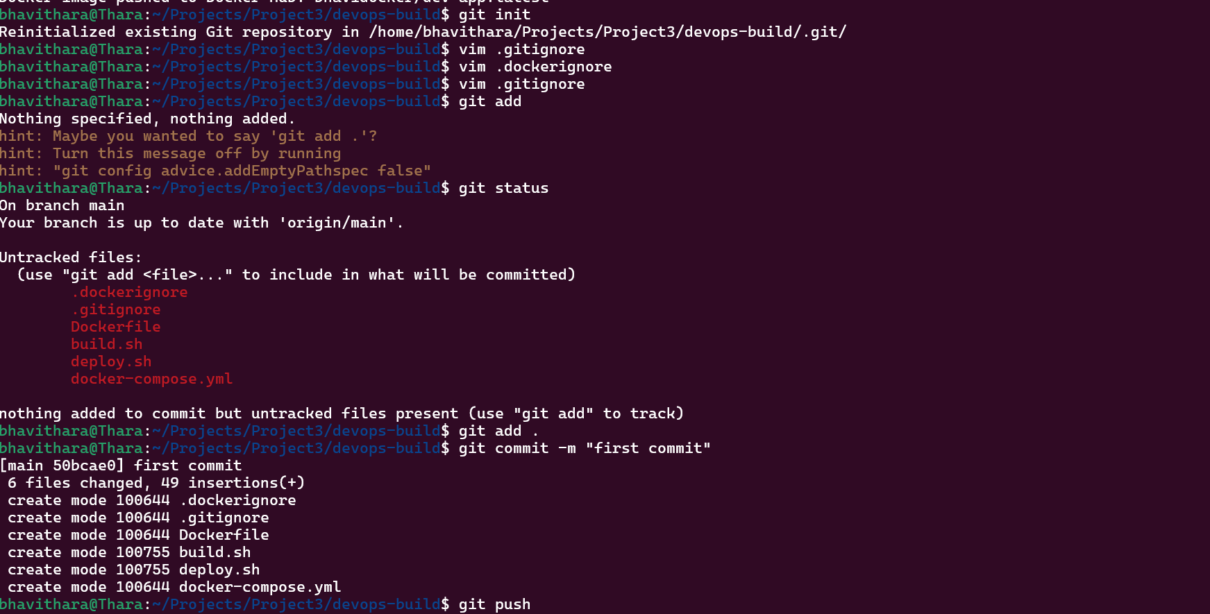

DockerHub:

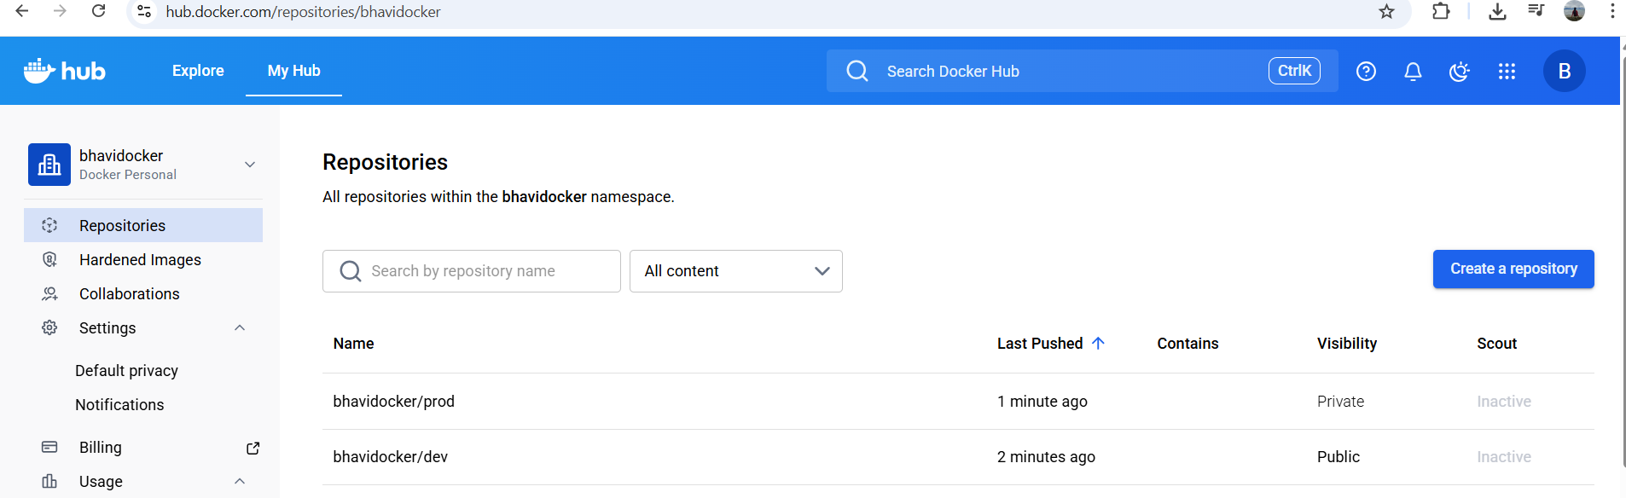

Jenkins:

Created Multibranch pipeline in Jenkins.

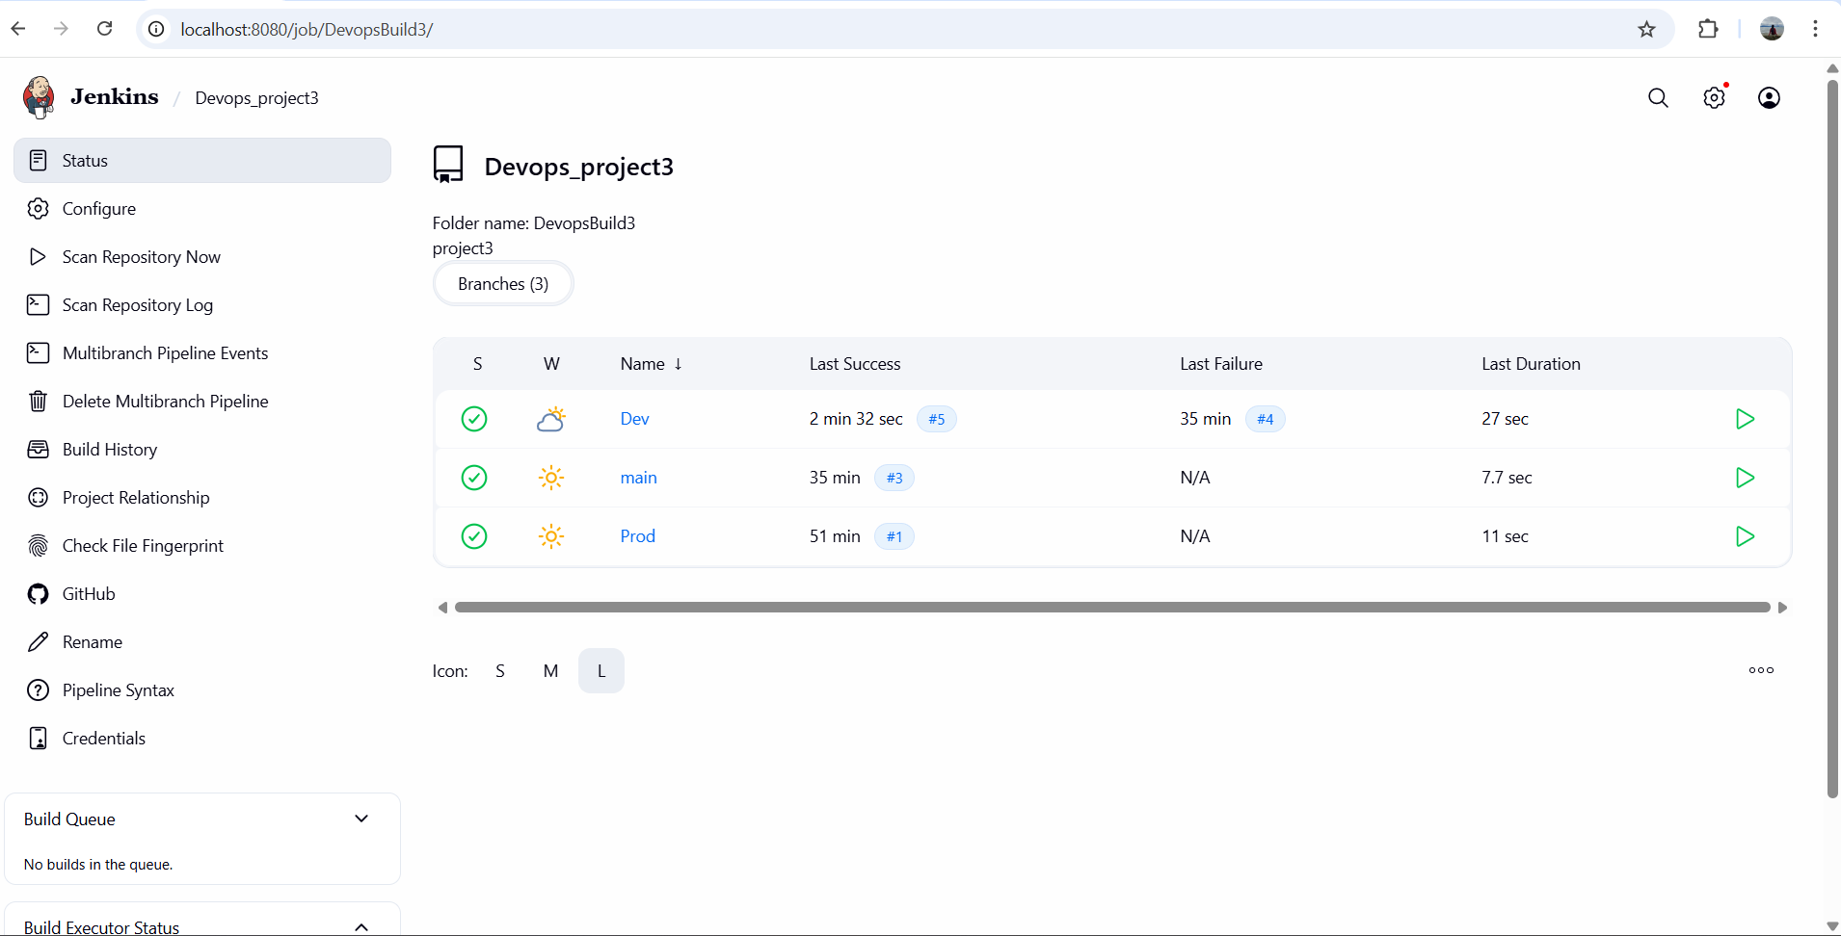

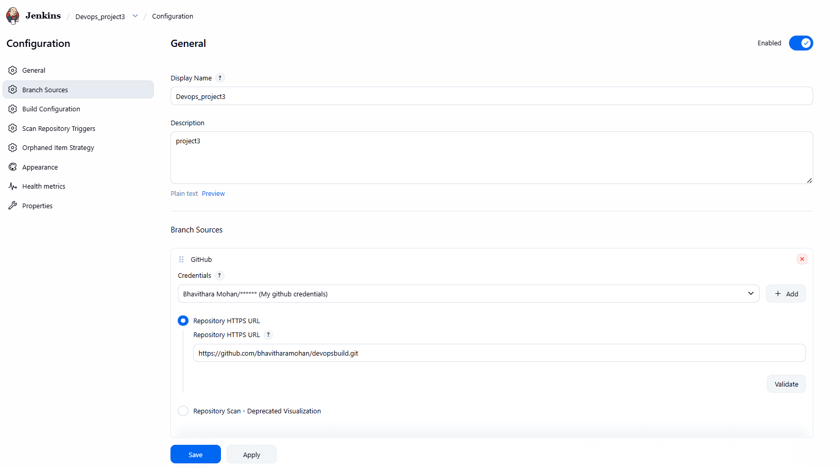

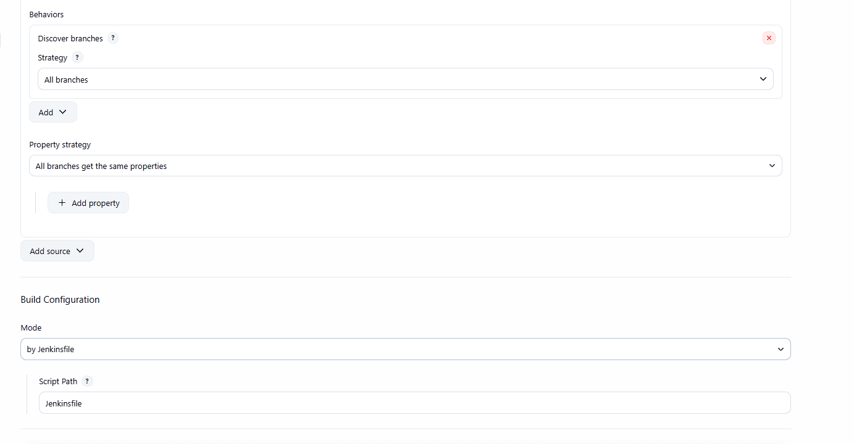

Configure webhook in github

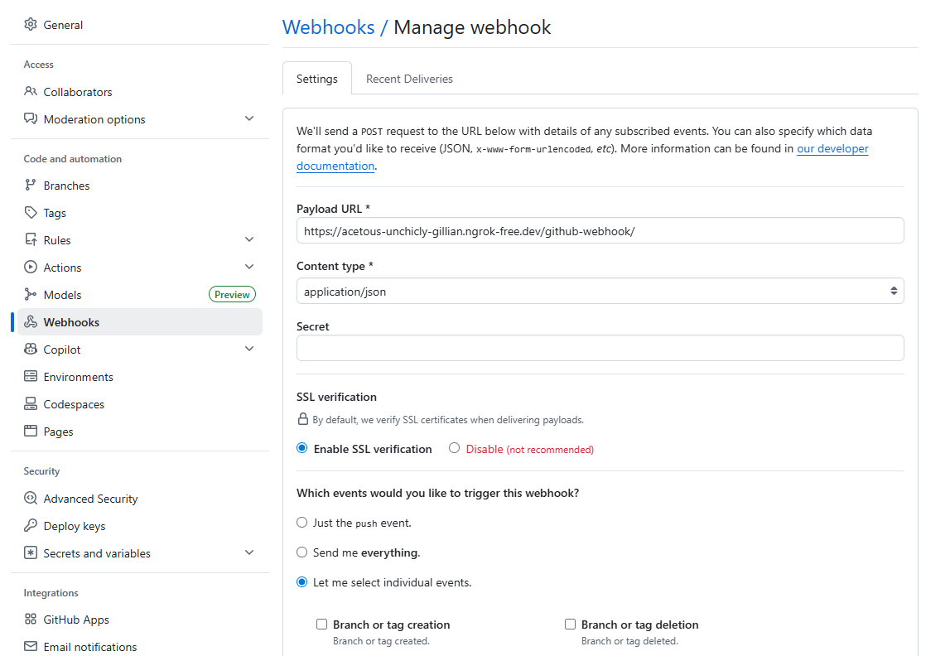

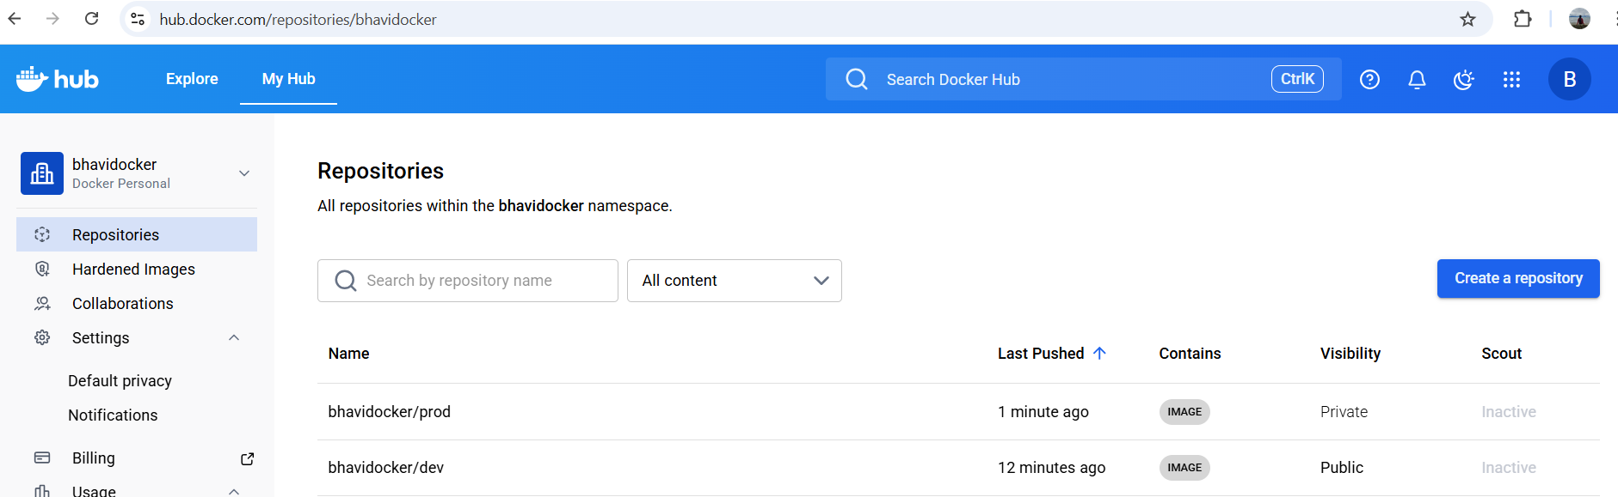

Added Jenkinsfile for this in git repo
Script:

pipeline {
agent any

environment {
DOCKER_USER = "bhavidocker"
}

stages {
stage('Build & Push') {
steps {
script {
if (env.BRANCH_NAME == "Dev") {
sh "docker build -t ${DOCKER_USER}/dev:latest ."
sh "docker push ${DOCKER_USER}/dev:latest"
}
else if (env.BRANCH_NAME == "Prod") {
sh "docker build -t ${DOCKER_USER}/prod:latest ."
sh "docker push ${DOCKER_USER}/prod:latest"
}
}
}
}
}
}

AWS:

EC2:
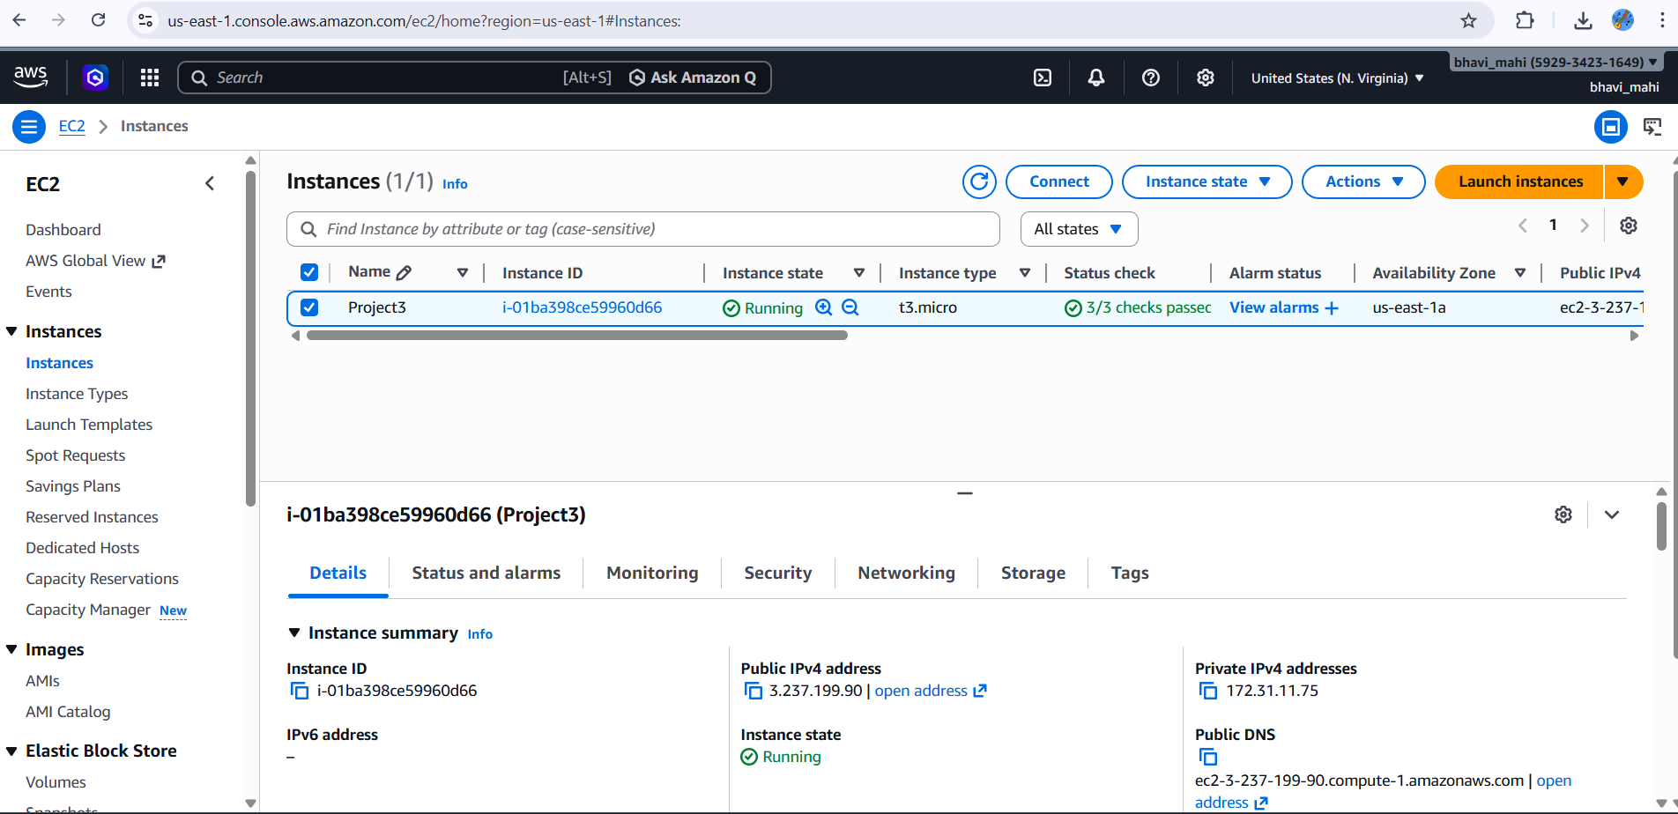

Security Group:

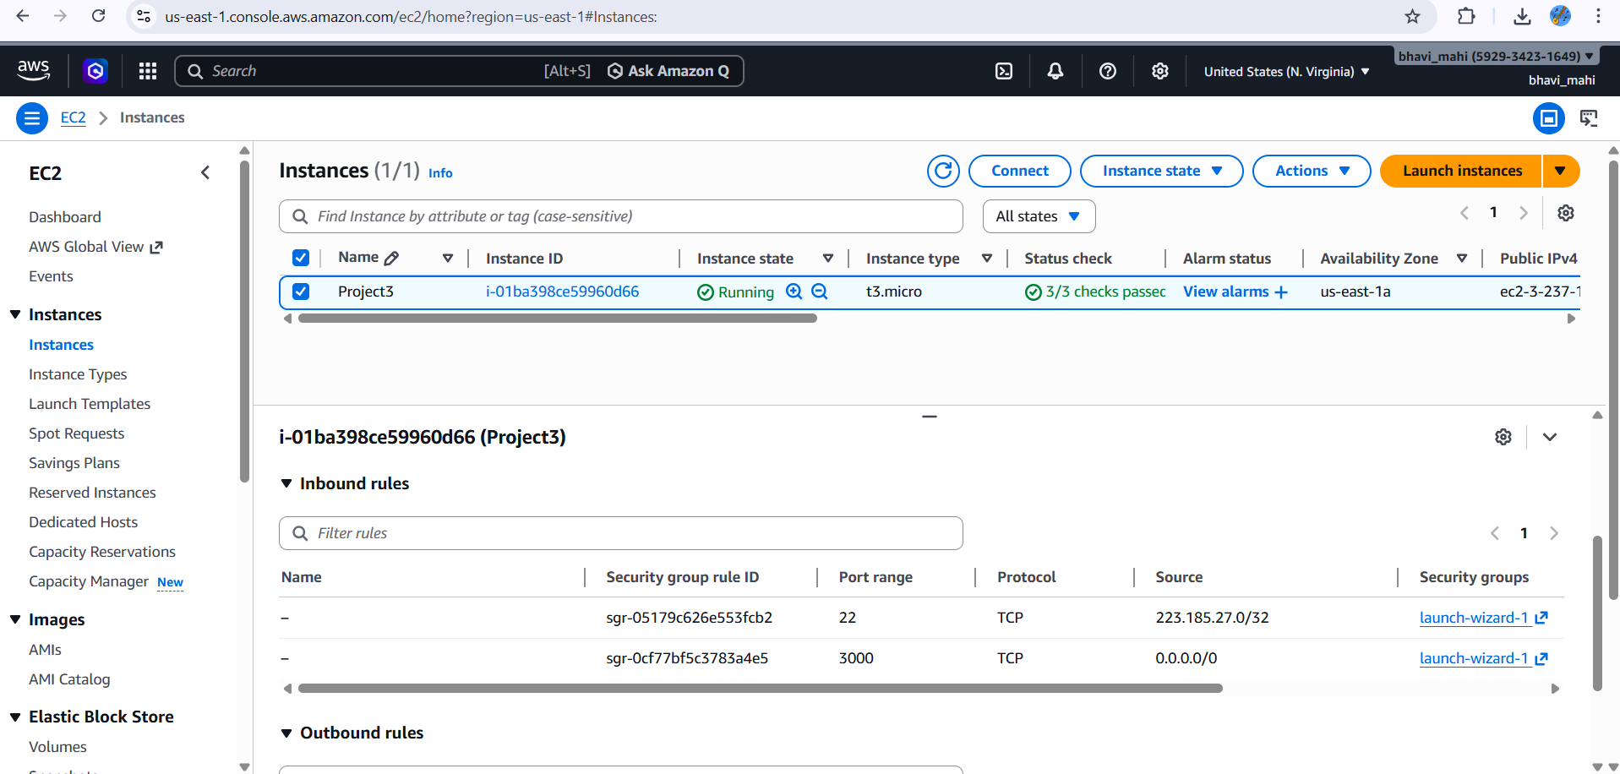

DockerHub Image tag:

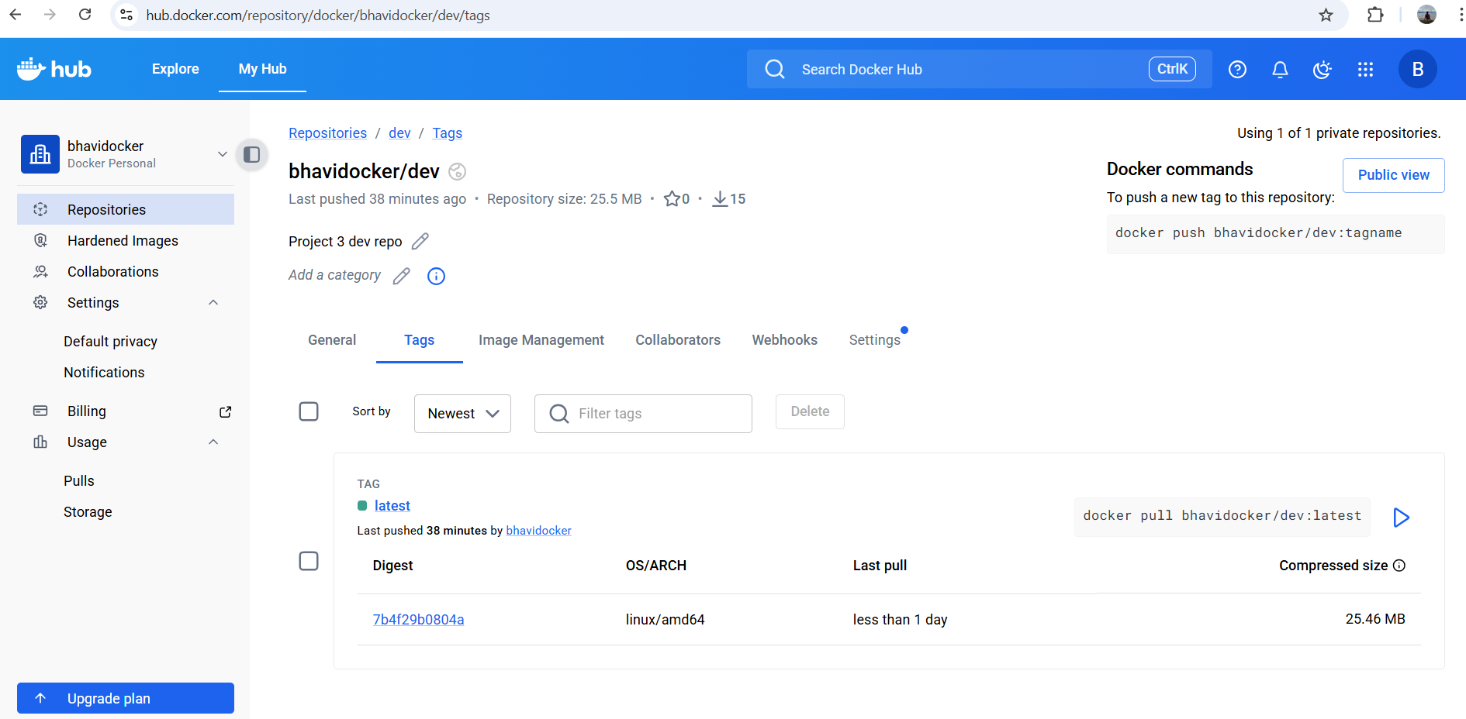

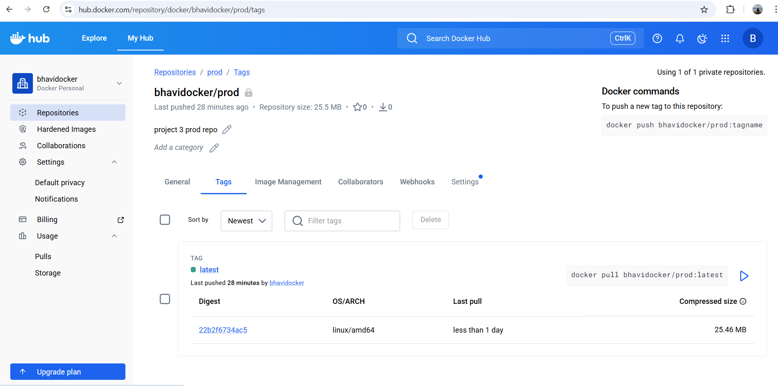

Deployed site page:

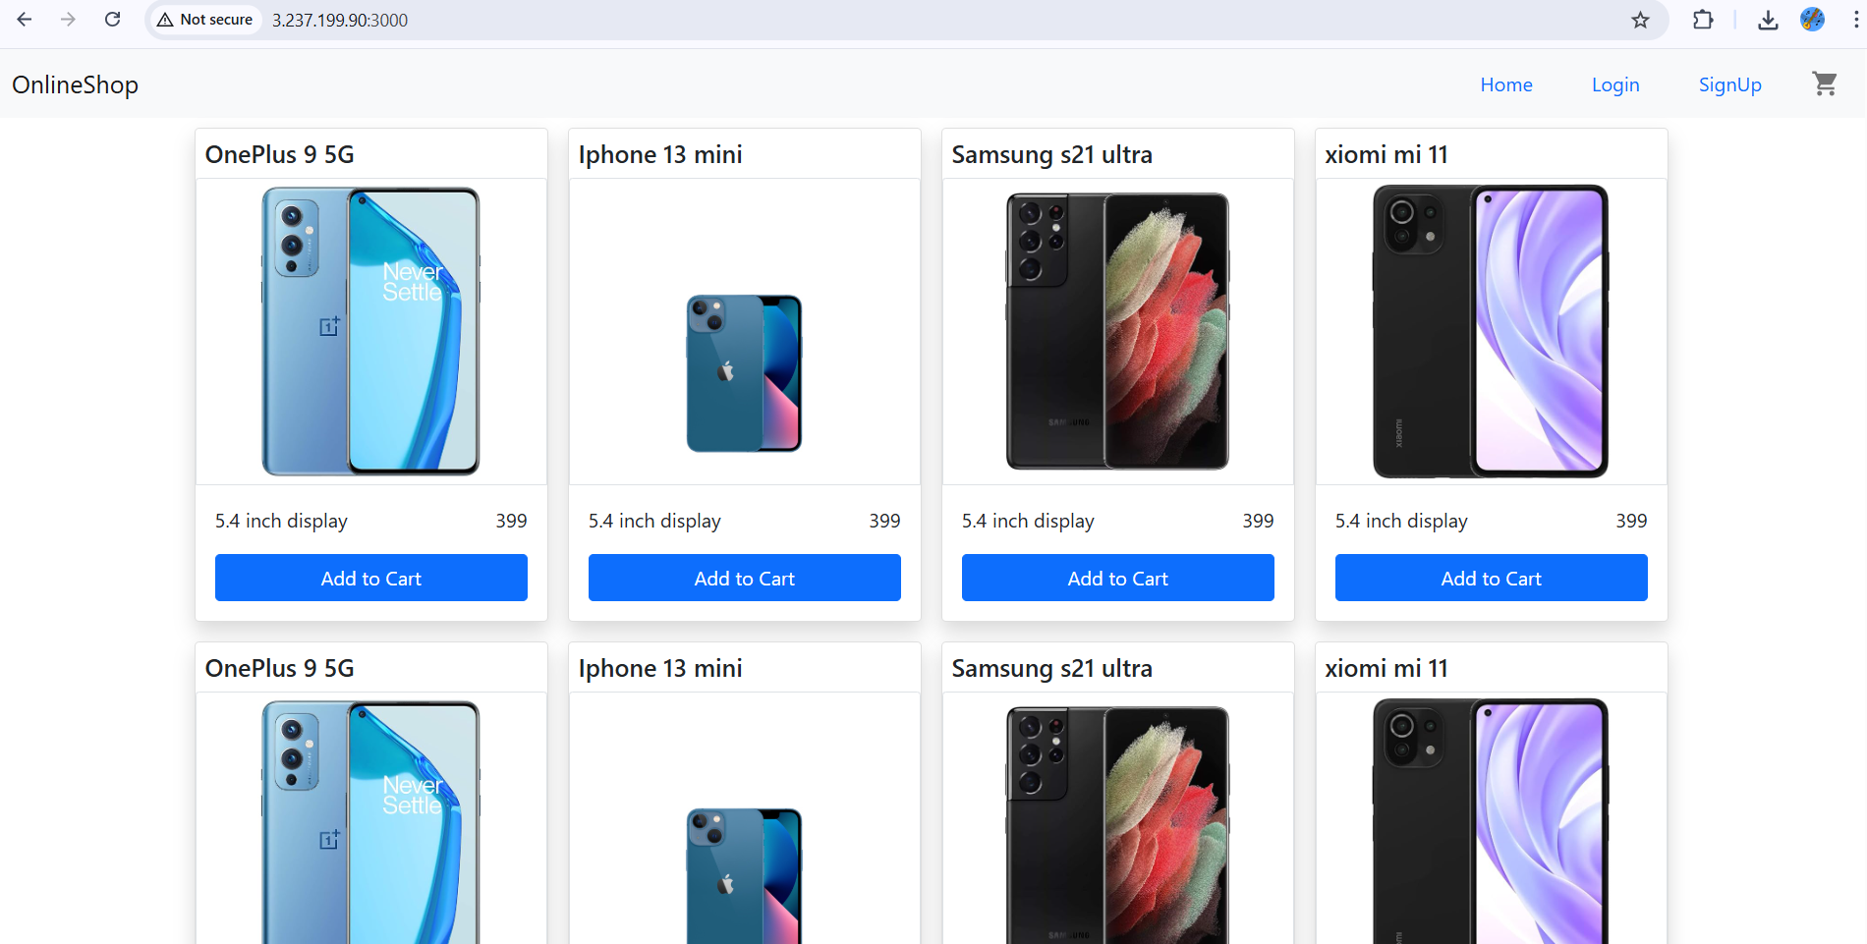

Monitoring:

Command used:

mkdir monitoring
cd monitoring
vim prometheus.yml
global:
scrape_interval: 15s

rule_files:
- "alert.rules.yml"

scrape_configs:
- job_name: "frontend-app"
metrics_path: /
static_configs:
- targets: ["3.237.199.90:3000"]

alerting:
alertmanagers:
- static_configs:
- targets:
- alertmanager:9093
Vim alert.rules.yml
groups:
- name: app-alerts
rules:
- alert: ApplicationDown
expr: up == 0
for: 1m
labels:
severity: critical
annotations:
summary: "Application Down"
description: "Application not reachable for more than 1 minute."

vim alertmanager.yml
global:
smtp_smarthost: 'smtp.gmail.com:587'
smtp_from: '******@gmail.com'
smtp_auth_username: '************@gmail.com'
smtp_auth_password: *************@1006'

route:
receiver: 'email-alert'

receivers:
- name: 'email-alert'
email_configs:
- to: '*************@gmail.com'

vim docker-compose.yml

version: "3"

services:

prometheus:
image: prom/prometheus
volumes:
- ./prometheus.yml:/etc/prometheus/prometheus.yml
- ./alert.rules.yml:/etc/prometheus/alert.rules.yml
ports:
- "9090:9090"

alertmanager:
image: prom/alertmanager
volumes:
- ./alertmanager.yml:/etc/alertmanager/alertmanager.yml
ports:
- "9093:9093"

docker-compose up -d

